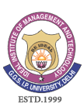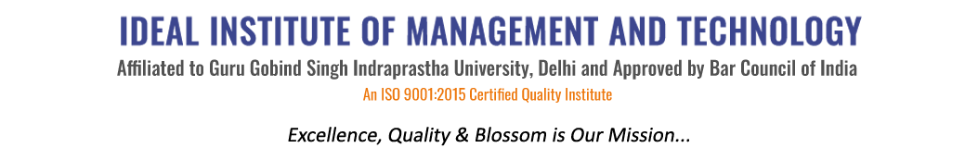
16 X, Karkardooma Institutional Area, (Near Telephone Exchange)
Delhi-110092
+91 (11) 22372639, 22375961,
http://idealinstitute.edu.in
SPORTS REPORT
The 17th Annual Sports Meet of Ideal Institute of Management & Technology and School of Law was held on 25th January, 2017 to promote a spirit of sportsmanship among the students. The function was presided over by Shri Mahender Ahuja. Alongwith him, we were honoured by the graciouspresence of VIJAY KUMAR SAROTIYA , S.H.O., Anand Vihar. The function started with the March Past by contingents of the different departments of the college lead by the contingent of the Ideal Student Council. It was followed by the Torch Ceremony led by SHOBHIT MATHUR and AKANSHA CHHABRA. The Oath Ceremony was conducted under the leadership of SAHAJ JAIN. The Annual Sports Meet had 20 Events in all (including both the Indoor and Outdoor Games). The winning students were awarded the Medals and Certificates. In order to encourage the students even the faculty members, Director and the members of the managing committee participated in the Sports Events.

JITENDER YADAV
SPORTS OFFICER
IIMT

